English Language Development
Fall Semester 2016
This course will focus on two areas:
1) Reading The Other Wes Moore: One Name, Two Fates and completing related activities.
2) Completing a document –based essay. It is similar to a research paper except that the research is provided for you.
CLASS RULES:
- Only the teacher answers the classroom door.
- Stay in your seat/Cell phones turned off and only in a backpack or purse- not a pocket.
- Only 1 pass is allowed out of class per week and only three students are allowed out of class in any one 50 minute period. Passes are at the discretion of the teacher.
Instructor: Ms. Stam Email: bes2699@lausd.net
Grading breakdown:
Grading | Textbooks and supplements
A 90-100%  B 79-89%  C 68-78%  D 67%-68%  F 66% and below  25 % of grade = writing assignments  25% of grade = reading logs/activities for your book  25% of grade = FINAL Comprehensive Report  NO SHOW FOR THE FINAL = FAIL THE CLASS  - Use black or blue ink only on assignments  - Points will be deducted for errors in spelling, grammar and sentence structure  www.amazon.com – 25 points extra credit if you buy book or check out from the library | 1) One non-fiction book : The Other Wes Moore: One Name, Two Fates by Wes Moore,  Video: The Other Wes Moore  2) DBQ Project essay : What Caused the Dust Bowl  6) FINAL EXAM:  1) Comprehensive Reading Report for The Other Wes Moore: One Name, Two Fates

Literature  The Other Wes Moore: One Name, Two Fates , 2010  Two African-American boys with the same name grew up in Baltimore during the 1980’s and 1990’s. They were both named Wes Moore. They faced many of the same challenges. One grew up to be a Rhodes Scholar and combat veteran and worked in the White House. The other is serving a life sentence for murder. The successful Wes Moore believes “my life could have been his, and his life could have been mine.” But is that really the case? We will look at factors beyond environment when deciding if the author’s thesis in this very riveting and illuminating book is sound. Could it be that he is too close to the story? Could he be reading too much into a name? Or is he correct that the tragedy is that opportunity is a matter of luck and good fortune for poor African-American youth? You decide. Your final essay will answer the question:  Is it really the “chilling truth that his story could have been mine and the tragedy is that my story could have been his?” Explain using details and examples from the T –chart you created during the reading.  https://www.youtube.com/watch?v=6bk_U6wHszE | 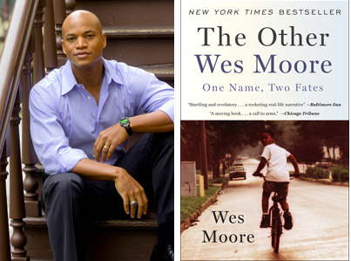  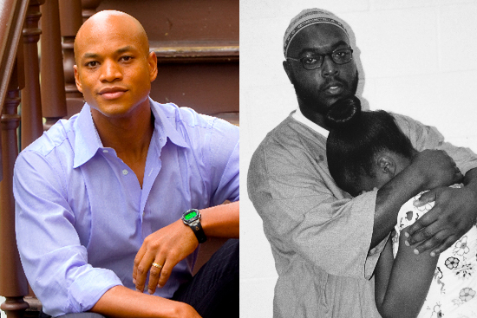
Document –based Essay  1) What Caused the Dust Bowl?  - Analyze visual and written documents  - Learn about the Okies and their trek to California, their culture, music and whether California was really the “promised land” for them.  - Write an essay answering the question, “What caused the Dust Bowl?” Use evidencde from the background essay, documents and supplementary lessons. Was the Dust Bowl inevitable given the actions of settlers in the late 1800’s? | 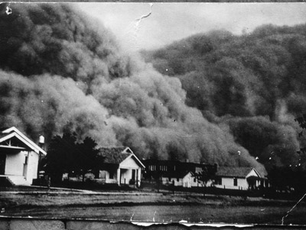

“Work hard, do the best you can, don’t ever lose faith in yourself and take no notice of what other people say about you.” Noel Coward
I understand that homework will be assigned in this class and I need to complete it in order to practice skills learned in class. Cell phones are to be turned off and kept in a backpack or purse, not a pocket. Otherwise, you the teacher must keep it until the end of class. I also understand that attendance is critical to success in ELD. No new work will be accepted the last week of school. Only revisions of prior work will be allowed to be turned in. Furthermore, most work has a firm deadline. This means if I am given two weeks to complete an assignment, I have between the first day and the 14th day to turn that work in. Being absent on the last day of the deadline is not an excuse for not turning in work as I have the previous 13 days to turn it in. I will plan to turn in assignments before the deadline to avoid missing it. Work will not be accepted after the deadline.
Student print name______________________________ Date _______________
Student signature ________________________________ Date ______________
I understand that my child will be assigned homework in this class and needs to complete this valuable practice for skills learned in the classroom. Frequent absences will make it difficult for your child to succeed in class. Please advise your child to keep his or her cell phone turned off in class and put it in a backpack or purse. Otherwise, the teacher will store it in a plastic bag with a card with your child’s name until the end of class. Assignments are given deadlines so please advise your son or daughter to complete work early. If they have an excused absence on the day of the deadline (doctor’s appointment or court) they need to turn in the work before that date. Babysitting, extended vacations and bad weather are not legitimate excuses for your child to miss school.

Parent print name________________________________ Date_______________
Parent signature _________________________________ Date _______________

